CSF LOGIc assignment

Mars MIPS Assembly

Pritam Sangani

16039231

# Task A

## Code

#TASK A

.data #tells assembler that we're in data segment

#variable declarations

enterName: .asciiz "Enter your name: "

printName: .asciiz "\nYour name is "

userInput: .space 20 #clear 20 bytes in memory for userInput

enterID: .asciiz "\nEnter the last four digits of your student ID number: "

printID: .asciiz "\nThe last four digits of your student ID number are "

.text #tells assembler that we're in text segment

#displayName

#print out enterName string

la $a0 enterName #load enterName into $a0 register

addi $v0 $zero 4 #load service number 4 (for printing a string) into $v0 register

syscall #call to system

#allow user to input their name

la $a0 userInput

addi $a1 $zero 20 #reserve 20 bytes of memory in $a1 register

addi $v0 $zero 8 #load service number 8 (for reading a string) into $v0 register

syscall

#displayID

#print out enterID string

la $a0 enterID

addi $v0 $zero 4

syscall

#read integer that user enters

addi $v0 $zero 5 #load service number 5 (for reading an integer) into $v0 register

syscall

#move integer stored in $v0 register to $t0 register

addu $t0 $zero $v0 #move into $t0 so data doesn't get overwritten

#print out printName string

la $a0 printName

addi $v0 $zero 4

syscall

#display name that user has entered

la $a0 userInput

addi $v0 $zero 4

syscall

#print out printID string

la $a0 printID

addi $v0 $zero 4

syscall

#print out integer that was entered by user

addi $v0 $zero 1 #load service number 1 (to print an integer) into $v0 register

addu $a0 $zero $t0 #move integer stored in $t0 register to $a0 register

syscall

## How the Program Works

I declared variables for the prompts I was going to use in the .data segment. The instructions went in the .text segment.

To display the name, I firstly loaded the enterName variable into $a0 and loaded service number 4 into $v0 to tell the system to print a string. I then reserved 20 bytes in $a1 to allow you to enter your name. I used service number 8 to read a string.

To display the ID, I used service number 5 to read an integer. To make sure the data was not overwritten I moved it from $v0 to $t0. I used service number 1 to print the integer and moved the data in $t0 to $a0.

## Screenshots of input and output stage

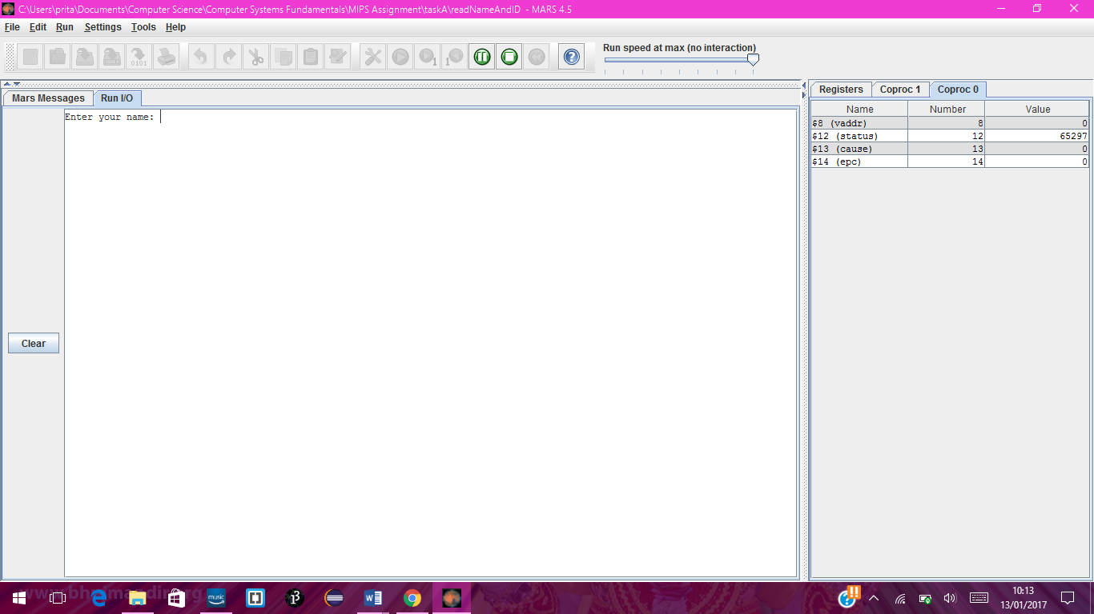

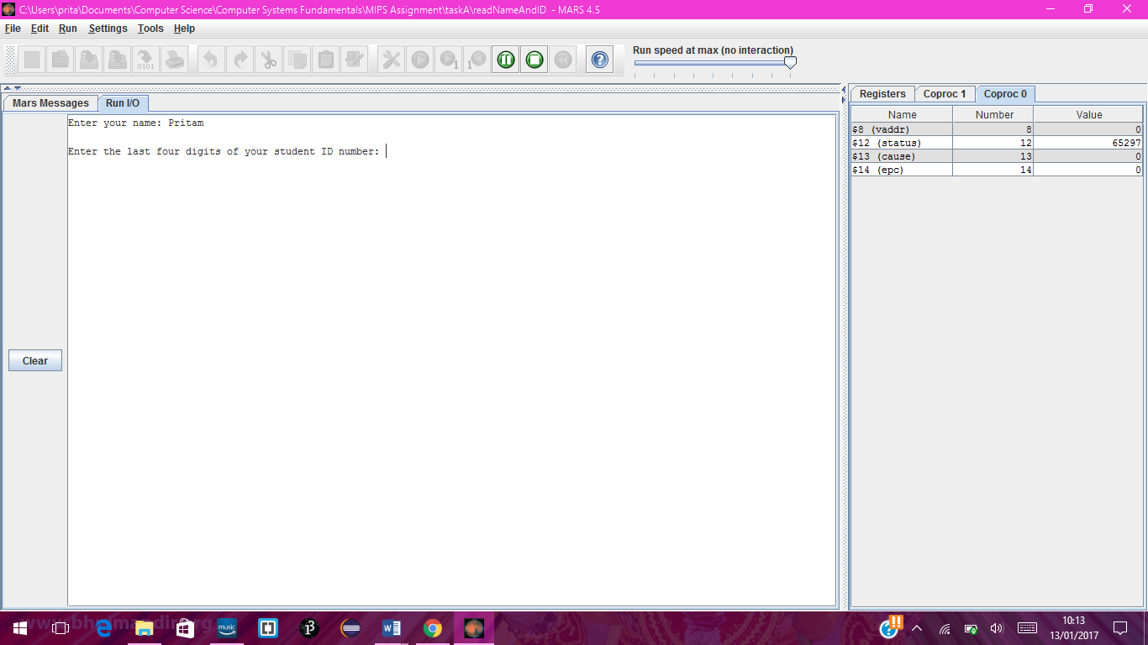

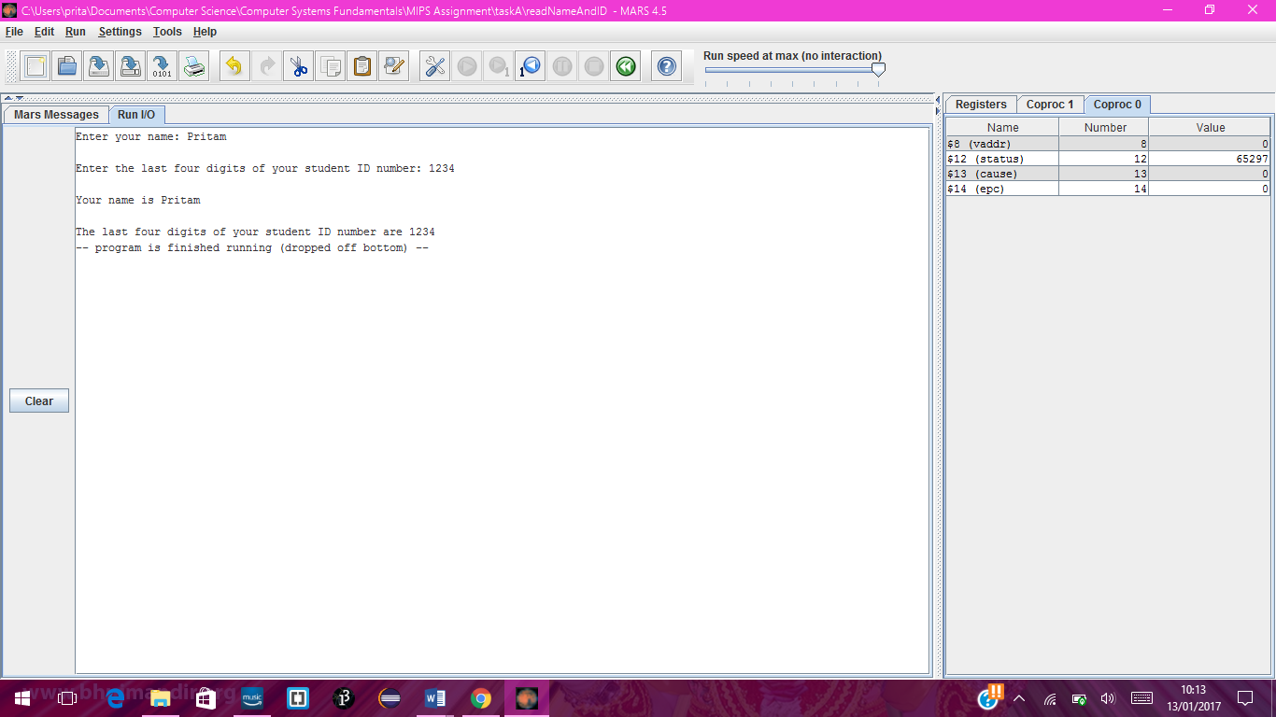

# Task B

## Code

#TASK B

.data #tells assembler that we're in data segment

#variable declarations

enterID: .asciiz "Enter the last three digits of your student ID number: "

printID: .asciiz "\nThe number you entered multiplied by 2 equals "

.text #tells assembler that we're in text segment

#print out enterID string

la $a0 enterID #load enterID variable into $a0 register

addi $v0 $zero 4 #load service number 4 (for printing out a string) into $v0 register

syscall #call to system

#read integer that user enters

addi $v0 $zero 5 #load service number 5 (for reading an integer) into $v0 register

syscall

#move integer stored in $v0 register to $t0 register

addu $t0 $zero $v0

mul $t1 $t0 2 #multiply number in $t0 by 2 and store in $t1

addi $t2 $zero 3 #add 3 to $t2

loop: #start of loop

#print out printID string

la $a0 printID

addi $v0 $zero 4

syscall

#print out integer that was entered by user

addi $v0 $zero 1 #load service number 1 (to print an integer) in $v0 register

#move integer stored in $t1 register to $a0 register

addu $a0 $zero $t1

syscall

addi $t2 $t2 -1 #take 1 away from number in $t2 each time it reaches this line

bgez $t2 loop #if number in $t2 is greater than or equal to zero go back to loop label and rerun code within the loop

## How the Program Works

To multiply the number by 2, I used the ‘mul’ instruction and stored the result in $t1.

For the loop, I first added 3 to $t2. I put all the instructions for the calculation happening in the loop inside a label which I called ‘loop’.

For the counter, I took one away from the number in $t2 each time the instructions in the loop had finished.

I used the ‘bgez’ instruction to test whether the loop had to occur again. This instruction checks whether the value of $t2 is greater than or equal to zero. If it is, it will branch the program back to the loop label and another loop will occur. Once the counter goes below zero the bgez instruction will tell the system to stop the loop structure.

## Screenshots of input and output stage

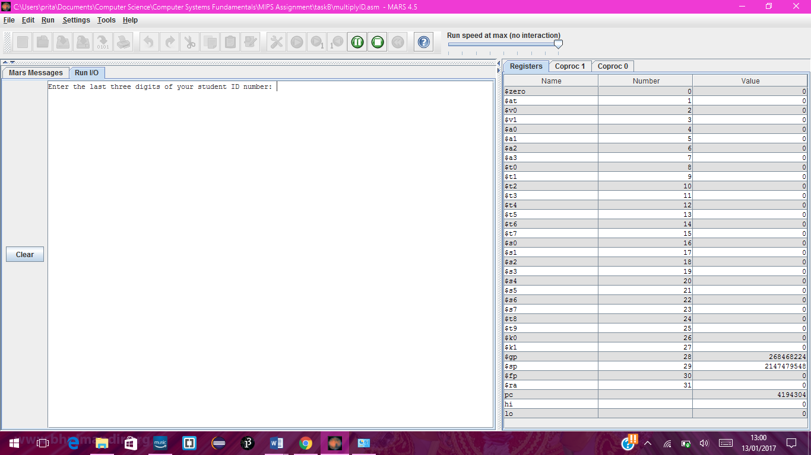

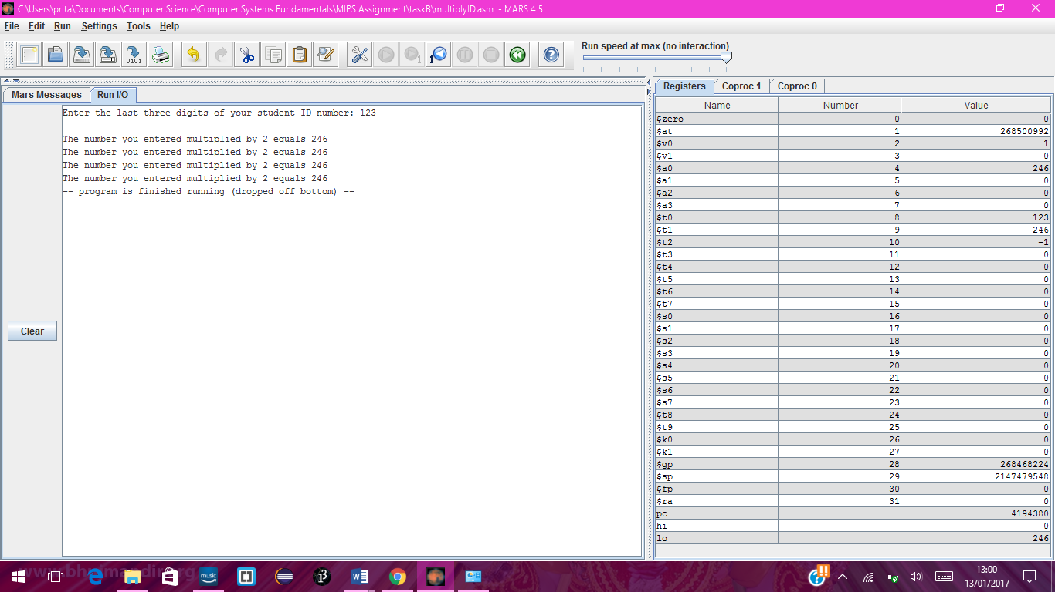

# Task C

## Code

#TASK C

.data #tells assembler that we're in data segment

#variable declarations

enterNo: .asciiz "\nEnter a three digit number: "

result: .asciiz "\nThe result of your calculation is: "

time: .asciiz "\nTotal time of calculation is: "

ms: .asciiz " ms"

.text #tells assembler that we're in text segment

#print out enterNo string

la $a0 enterNo #load enterNo into $a0 register

addi $v0 $zero 4 #load service number 4 (for printing a string) into $v0

syscall #call for system

#read integer that user enters

addi $v0 $zero 5 #load service number 5 (for reading an integer) into $v0 register

syscall

move $t0 $v0 #move integer stored in $v0 register to $t0 register

#get system time for just before loop structure begins

li $v0 30 #load service number 30 (for system time) into $v0 register

syscall

move $t5 $a0 #move time stamp data from $a0 into $t5 register

#instructions for loop structure

addi $t1 $zero 50 #add 50 to $t1 (counter for loopOuter)

loopOuter:

addi $t3 $zero 100 #add 100 to $t3 (counter for loopInner1)

loopInner1:

addi $t4 $zero 500 #add 50 to $t4 (counter for loopInner2)

loopInner2:

addi $t4 $t4 -1 #take 1 away from $t4 each time loopInner2 occurs

div $t2 $t0 7 #divide number stored in $t0 (entered by user) by 7 and store answer in $t2

bgez $t4 loopInner2 #if number in $t4 is greater than or equal to zero go back to loopInner2 label and rerun code within the loop

addi $t3 $t3 -1

bgez $t3 loopInner1

addi $t1 $t1 -1

bgez $t1 loopOuter

#get system time for just after loop structure has ended

li $v0 30 #record timestamp for the end of the loop structure

syscall

move $t6 $a0

#get total time for loop structure

sub $t7 $t6 $t5 #subtract $t5 from $t6 to get total time for the loop structure

#print out result string

la $a0 result

addi $v0 $zero 4

syscall

#print out result of calculation (integer)

addi $v0 $zero 1

move $a0 $t2

syscall

#print out time string

la $a0 time

addi $v0 $zero 4

syscall

#print out the total time for loop structure

addi $v0 $zero 1

move $a0 $t7

syscall

#print out ms string (displayed after total time)

la $a0 ms

addi $v0 $zero 4

syscall

## How the Program Works

To get the system time, I loaded service number 30 into $v0 just before the loop structure began and after it finished. To get the total time for the loop structure, I took the time recorded before the loop structure had started away from the time recorded after the loop structure had ended. This was done using the ‘sub’ instruction.

As the system time is outputted in milliseconds, I displayed ‘ms’ after the time to tell the user that the time was in milliseconds.

For the loop structure, I had two inner loops nested inside an outer loop. For the outer loop labelled ‘loopOuter’. I added 50 to $t1, which acted as the counter for the outer loop. Within that loop, I had the first inner loop labelled as ‘loopInner1’. For the counter for this loop, I added 100 to $t3. Within this was the inner-most loop labelled as ‘loopInner2’. For the counter for this loop, I added 500 to $t4. I put the instruction for the calculation inside this loop. I divided the data that was stored in $t0 by 7 and then stored the result in $t2. I then used the ‘bgez’ instruction to check whether the loop counter is greater than or equal to zero. This was done at the end of each loop.

## Screenshots of input and output stage

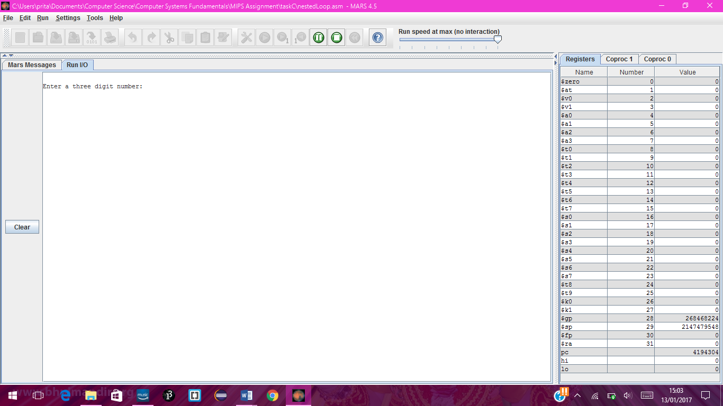

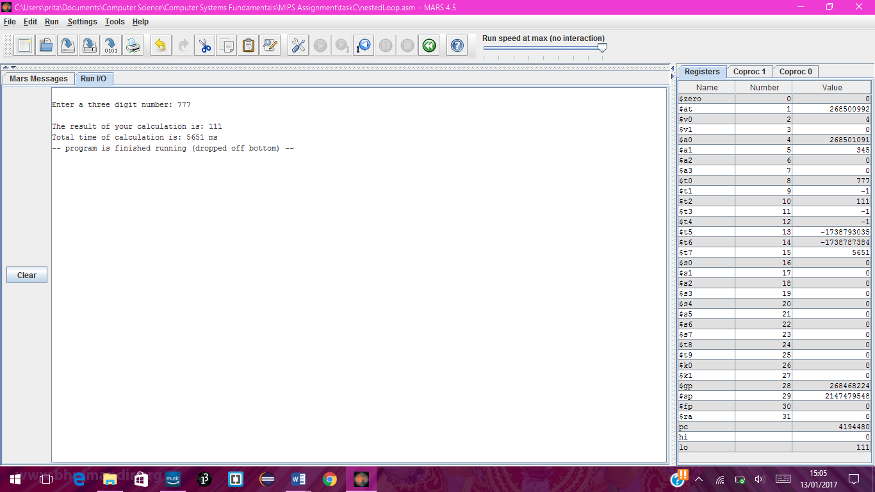

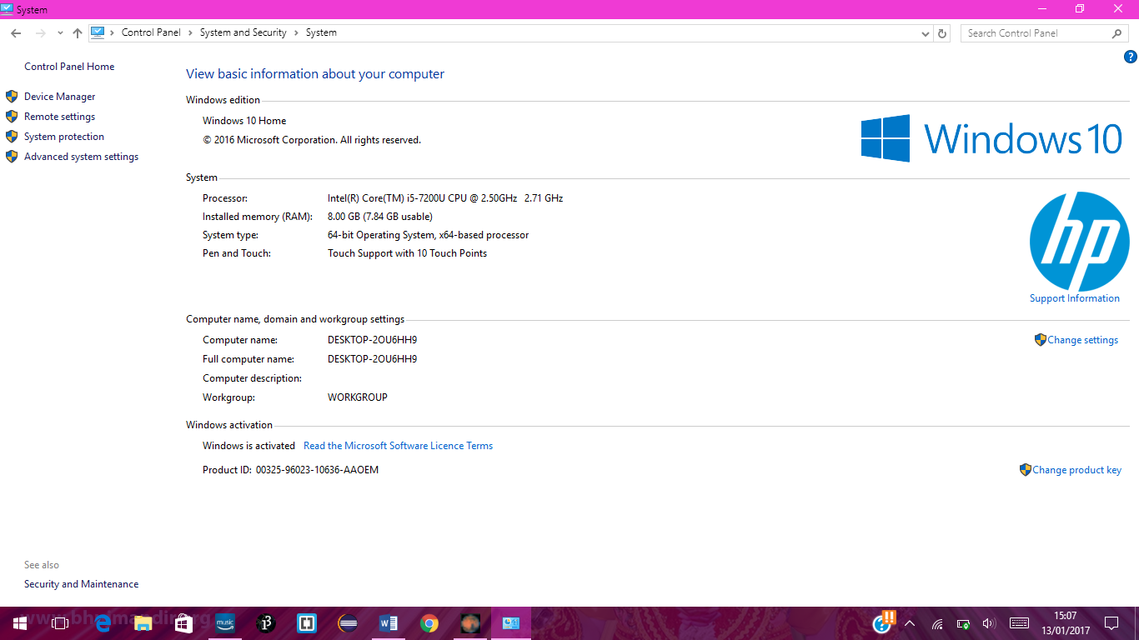

## Flow chart for Part C

Start

Print out prompt to enter number

Read in integer

Get system time

Start loopOuter

Start loopInner1

Start loopInner2

Do calculation

Yes

Is counter greater than or equal to zero

No

Yes

Is counter greater than or equal to zero

No

No

Yes

Print result of calculation

Is counter greater than or equal to zero

Subtract system times to get total time

Finish

Print time of loop structure

Get system time